# Rabobank Exercise

## Background

Fund of mandates has recently been introduced for our investment clients. Our clients hold positions in their portfolio that can be made up of various funds. Some, not all, of these funds can be made up of funds of mandates, where mandate allocations are defined for the entire fund and is therefore applicable to all clients that hold these positions.

In order to get the mandate allocations for the funds of mandates, we import an xml file that contains the current allocations. The portfolio positions are then enriched with this additional information to provide all the current positions to the client, including the mandate allocations on funds of mandates.

The classes in the library are defined as follows:

**Portfolio** **Position** **Mandate**

Property Type Property Type Property Type

Positions List<Position> Code string Name string

Name string Allocation decimal

Value decimal Value decimal

Mandates List<Mandate>

Portfolio positions are linked to funds of mandates by matching the FundOfMandates InstrumentCode with the Position Code. The Value for the Mandate is calculated using the Position Value and the Mandate Allocation percentage. In addition to this, if the fund of mandate has a liquidityAllocation, an additional Liquidity mandate is added, the value of which is calculated using the Position Value and the LiquidityAllocation percentage.

For example, you have the following Position:

Code Name Value

NL0000292332 Rabobank Core Aandelen Fonds T2 45678

And the following fundOfMandates:

instrumentCode name liquidityAllocation

NL0000292332 Rabobank Core Aandelen Fonds T2 1

With mandates:

mandate-id mandateName allocation

NL0000292332-01 Vanguard MSCI world mandaat 49.6

NL0000292332-02 Blackrock World Stock mandaat 49.4

In this case you should end up with the following Position object:

Code Name Value

NL0000292332 Rabobank Core Aandelen Fonds T2 45678

Mandates:

Name Allocation Value

Vanguard MSCI world mandaat 0.496 22656

Blackrock World Stock mandaat 0.494 22565

Liquidity 0.01 457

## The Code

Open the .\Rabobank.Intake\Rabobank.Intake.sln in Visual Studio 2019. You should see 3 projects:

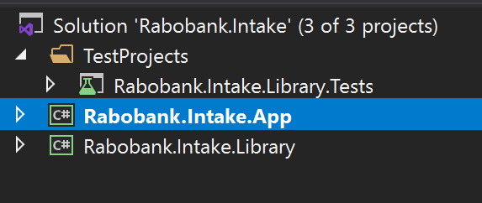

When you run the Rabobank.Intake.App project you will see the following:

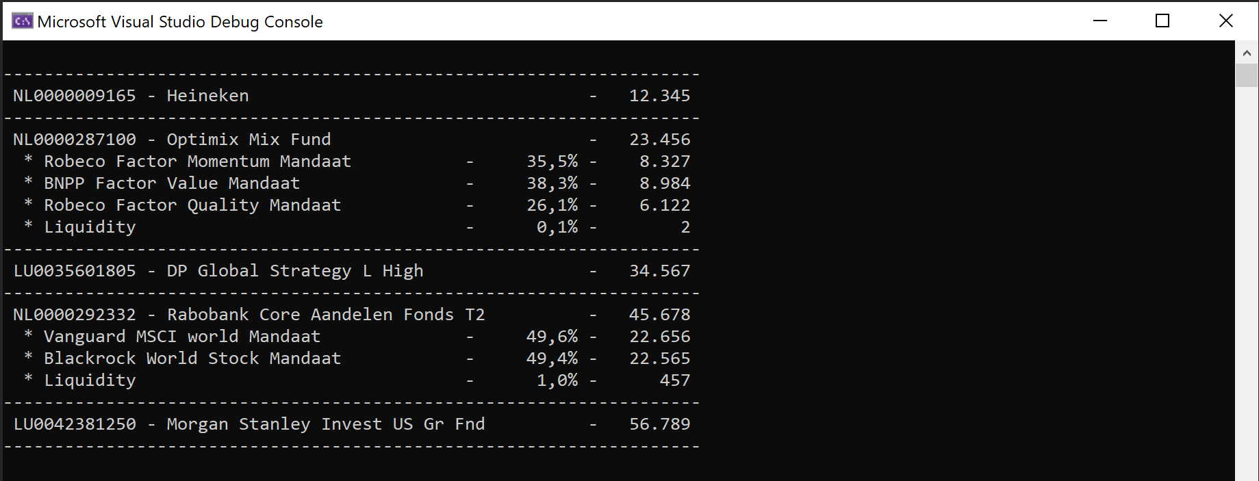

## Requirements

You have been assigned the responsibility to maintain the **Rabobank.Intake.Library** project. This library can be used by several other teams and the Rabobank.Intake.App is an example of how it would be used.

The library currently works as expected but the code and tests can be improved. In this exercise we simply want you to refactor the code in the Rabobank.Intake.Library project and ensure that the code is sufficiently tested. All tests for the Rabobank.Intake.Library project can be found in the **Rabobank.Intake.Library.Tests** project.